**OOP case study**

**Topic: Tic Tac Toe**

**By:**

**Shraddha Singh(20030121106)**

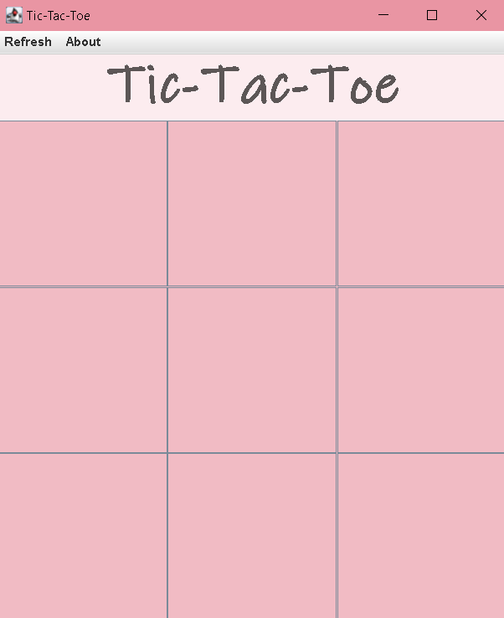

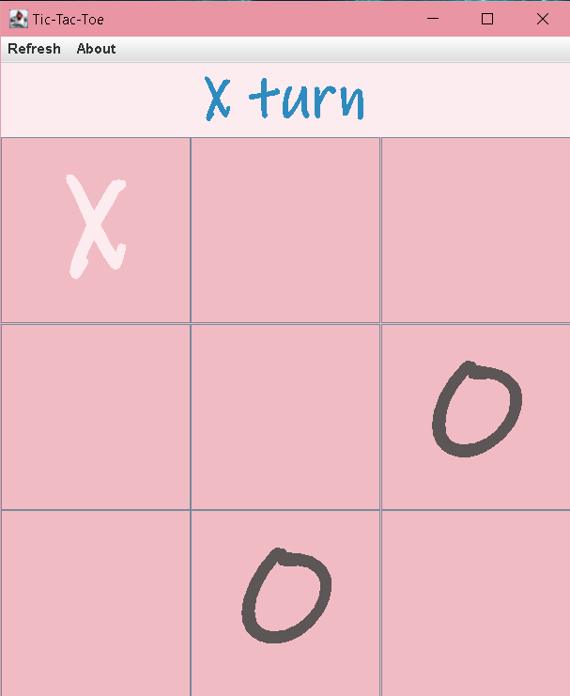

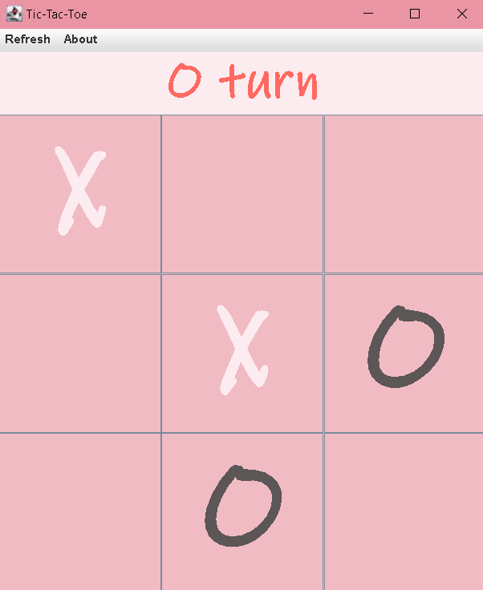

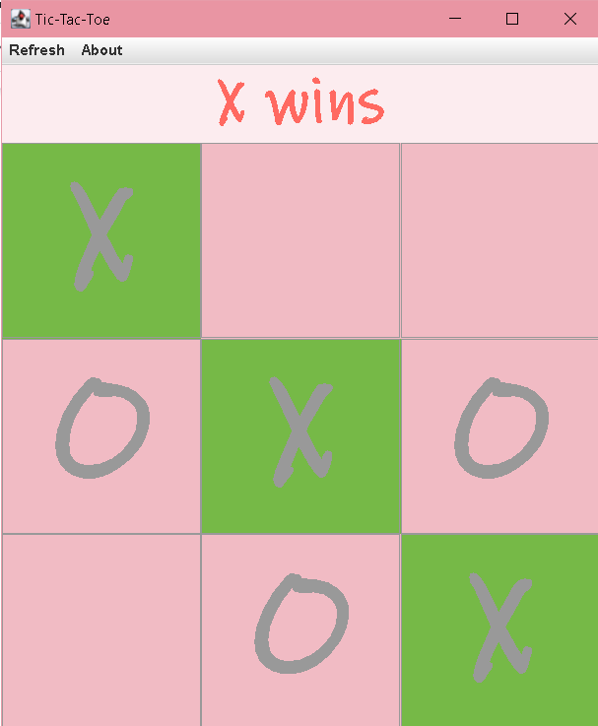

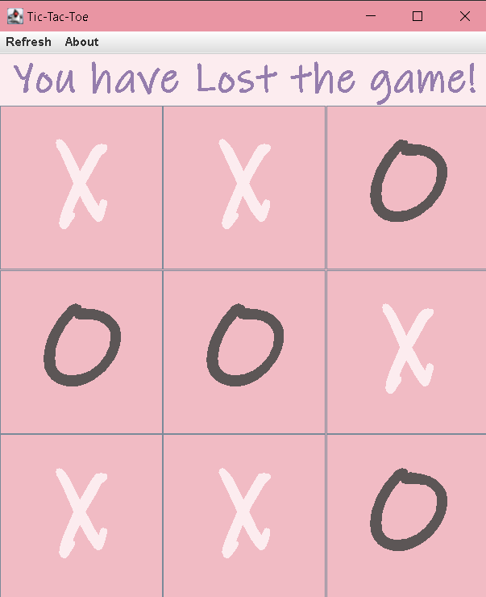

**Code:**

**import javax.swing.*;**

**import java.awt.*;**

**import java.awt.event.ActionEvent;**

**import java.awt.event.ActionListener;**

**import java.util.Random;**

**public class TicTacToe implements ActionListener{**

**JMenuBar menuBar;**

**JMenu Refresh, About;**

**JMenuItem Start, AbtHelp;**

**Random random = new Random();**

**JFrame frame = new JFrame();**

**JPanel topPanel = new JPanel();**

**JPanel buttonPanel = new JPanel();**

**JLabel text = new JLabel();**

**JButton[] buttons = new JButton[9];**

**boolean firstPlayer;**

**TicTacToe(){**

**menuBar = new JMenuBar();**

**Refresh = new JMenu("Refresh");**

**Start = new JMenuItem("Start");**

**Start.addActionListener(this);**

**Refresh.add(Start);**

**menuBar.add(Refresh);**

**About = new JMenu("About");**

**AbtHelp = new JMenuItem("About Creator");**

**AbtHelp.addActionListener(this);**

**About.add(AbtHelp);**

**menuBar.add(About);**

**frame.setTitle("Tic-Tac-Toe");**

**frame.setDefaultCloseOperation(JFrame.EXIT_ON_CLOSE);**

**frame.setSize(500,600);**

**frame.getContentPane().setBackground(new Color(241,187,196));**

**frame.setLayout(new BorderLayout());**

**frame.setVisible(true);**

**text.setBackground(new Color(252,236,239));**

**text.setForeground(new Color(92,86,86));**

**text.setFont(new Font("Ink Free",Font.BOLD,50));**

**text.setHorizontalAlignment(JLabel.CENTER);**

**text.setText("Tic-Tac-Toe");**

**text.setOpaque(true);**

**topPanel.setLayout(new BorderLayout());**

**topPanel.setBounds(0,0,800,100);**

**buttonPanel.setLayout(new GridLayout(3,3));**

**buttonPanel.setBackground(new Color(241,187,196));**

**for(int i=0; i<9;i++){**

**buttons[i] = new JButton();**

**buttonPanel.add(buttons[i]);**

**buttons[i].setBackground(new Color(241,187,196));**

**buttons[i].setFont(new Font("Ink Free",Font.BOLD,120));**

**buttons[i].setFocusable(false);**

**buttons[i].addActionListener(this);**

**}**

**topPanel.add(text);**

**frame.add(topPanel,BorderLayout.NORTH);**

**frame.add(buttonPanel);**

**frame.setJMenuBar(menuBar);**

**frame.setVisible(true);**

**randomfirstTurn();**

**}**

**@Override**

**public void actionPerformed(ActionEvent e) {**

**if(e.getSource()==Start) {**

**for(int i=0; i<9;i++){**

**buttons[i].setText("");**

**buttons[i].setBackground(new Color(241,187,196));**

**buttons[i].setEnabled(true);**

**}**

**text.setForeground(new Color(92,86,86));**

**text.setFont(new Font("Ink Free",Font.BOLD,50));**

**randomfirstTurn();**

**}**

**if(e.getSource()==AbtHelp) {**

**String detail = "This Was Created By BCA Symbiosis Students = \n\n20030121068\t - \tNalamati Ooha Sai Sameera\n\n20030121098\t - \tSanskar Rohatgi\n\n20030121106\t - \tShraddha Singh\n\n20030121113\t - \tTanishq Nakra\n\n20030121144\t - \tSilas Sud\n\n\n";**

**JOptionPane.showMessageDialog(frame,detail);**

**}**

**for(int i=0;i<9;i++) {**

**if(e.getSource()==buttons[i]) {**

**if(firstPlayer) {**

**if(buttons[i].getText()=="") {**

**buttons[i].setForeground(new Color(252,236,239));**

**buttons[i].setText("X");**

**firstPlayer=false;**

**text.setForeground(new Color(255,105,97));**

**text.setText("O turn");**

**check();**

**}**

**}**

**else {**

**if(buttons[i].getText()=="") {**

**buttons[i].setForeground(new Color(92,86,86));**

**buttons[i].setText("O");**

**firstPlayer=true;**

**text.setForeground(new Color(46,139,192));**

**text.setText("X turn");**

**check();**

**}**

**}**

**}**

**}**

**}**

**public void randomfirstTurn(){**

**if(random.nextInt(2)==0) {**

**firstPlayer=true;**

**text.setText("X turn");**

**}**

**else {**

**firstPlayer=false;**

**text.setText("O turn");**

**}**

**}**

**public void check() {**

**if(**

**(buttons[0].getText()=="X") &&**

**(buttons[1].getText()=="X") &&**

**(buttons[2].getText()=="X")**

**) {**

**ifXwins(0,1,2);**

**}**

**if(**

**(buttons[3].getText()=="X") &&**

**(buttons[4].getText()=="X") &&**

**(buttons[5].getText()=="X")**

**) {**

**ifXwins(3,4,5);**

**}**

**if(**

**(buttons[6].getText()=="X") &&**

**(buttons[7].getText()=="X") &&**

**(buttons[8].getText()=="X")**

**) {**

**ifXwins(6,7,8);**

**}**

**if(**

**(buttons[0].getText()=="X") &&**

**(buttons[3].getText()=="X") &&**

**(buttons[6].getText()=="X")**

**) {**

**ifXwins(0,3,6);**

**}**

**if(**

**(buttons[1].getText()=="X") &&**

**(buttons[4].getText()=="X") &&**

**(buttons[7].getText()=="X")**

**) {**

**ifXwins(1,4,7);**

**}**

**if(**

**(buttons[2].getText()=="X") &&**

**(buttons[5].getText()=="X") &&**

**(buttons[8].getText()=="X")**

**) {**

**ifXwins(2,5,8);**

**}**

**if(**

**(buttons[0].getText()=="X") &&**

**(buttons[4].getText()=="X") &&**

**(buttons[8].getText()=="X")**

**) {**

**ifXwins(0,4,8);**

**}**

**if(**

**(buttons[2].getText()=="X") &&**

**(buttons[4].getText()=="X") &&**

**(buttons[6].getText()=="X")**

**) {**

**ifXwins(2,4,6);**

**}**

**//check O win conditions**

**if(**

**(buttons[0].getText()=="O") &&**

**(buttons[1].getText()=="O") &&**

**(buttons[2].getText()=="O")**

**) {**

**ifOwins(0,1,2);**

**}**

**if(**

**(buttons[3].getText()=="O") &&**

**(buttons[4].getText()=="O") &&**

**(buttons[5].getText()=="O")**

**) {**

**ifOwins(3,4,5);**

**}**

**if(**

**(buttons[6].getText()=="O") &&**

**(buttons[7].getText()=="O") &&**

**(buttons[8].getText()=="O")**

**) {**

**ifOwins(6,7,8);**

**}**

**if(**

**(buttons[0].getText()=="O") &&**

**(buttons[3].getText()=="O") &&**

**(buttons[6].getText()=="O")**

**) {**

**ifOwins(0,3,6);**

**}**

**if(**

**(buttons[1].getText()=="O") &&**

**(buttons[4].getText()=="O") &&**

**(buttons[7].getText()=="O")**

**) {**

**ifOwins(1,4,7);**

**}**

**if(**

**(buttons[2].getText()=="O") &&**

**(buttons[5].getText()=="O") &&**

**(buttons[8].getText()=="O")**

**) {**

**ifOwins(2,5,8);**

**}**

**if(**

**(buttons[0].getText()=="O") &&**

**(buttons[4].getText()=="O") &&**

**(buttons[8].getText()=="O")**

**) {**

**ifOwins(0,4,8);**

**}**

**if(**

**(buttons[2].getText()=="O") &&**

**(buttons[4].getText()=="O") &&**

**(buttons[6].getText()=="O")**

**) {**

**ifOwins(2,4,6);**

**}**

**if(text.getText().toString()=="X turn" || text.getText().toString()=="O turn"){**

**int j =0;**

**for(int i=0; i<9;i++){**

**if(!buttons[i].getText().isEmpty()){**

**j += 1;}**

**if(j==9){**

**text.setFont(new Font("Ink Free",Font.BOLD,40));**

**text.setForeground(new Color(149, 125, 173));**

**text.setText("You have Lost the game!");**

**}**

**}**

**}**

**}**

**public void ifXwins(int a, int b, int c) {**

**buttons[a].setBackground(new Color(118,185,71));**

**buttons[b].setBackground(new Color(118,185,71));**

**buttons[c].setBackground(new Color(118,185,71));**

**for(int i=0;i<9;i++) {**

**buttons[i].setEnabled(false);**

**}**

**text.setText("X wins");**

**}**

**public void ifOwins(int a, int b, int c) {**

**buttons[a].setBackground(new Color(118,185,71));**

**buttons[b].setBackground(new Color(118,185,71));**

**buttons[c].setBackground(new Color(118,185,71));**

**for(int i=0;i<9;i++) {**

**buttons[i].setEnabled(false);**

**}**

**text.setText("O wins");**

**}**

**public static void main(String[] args) {**

**new TicTacToe();**

**}**

**}**